Year 6 HOMEWORK-Summer Term
Title- Legacy Key Concepts: change, pride, possibility
Key Question: How can I make a difference in the world?
This term you will have the choice of topic related homework activities. You will be expected to complete a minimum of 1 piece of homework each week (except SATS week!) with at least 6 from the writing column during the term. You may complete more pieces of homework if you wish. All homework completed should be of your best standard and will gain you house points.
WRITING | CREATIVE
Research and write about 1960s and 1970s British children’s television series: Bagpus, The Flumps, Ivor The Engine, Blue Peter, Jackanory, Mr Benn, Rainbow, The Wombles, watch With Mother, Thunderbirds, Look and Read … | Design an outfit suited to the 1960s/1970s.  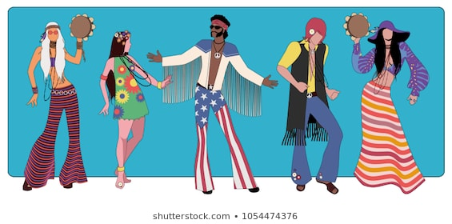
Research and write about the changes in fashion in the 1960s and 1970s. Here’s a few ideas:  1960 Doc Martens boots  1962 Teddy Boy suits  1963 Mop top hair  1964 Wigs  1965 The Twiggy look  1966 Mini skirts  1967 Paisley  1968 Body art  1969 Love beads | Make a 1970s string art picture. https://www.youtube.com/watch?v=xjO6MkV5_LI
Research and write about popular toys from 1960s/1970s: Matchbox cars, Lego, Raggedy Ann and Andy, Viewmaster, Spirograph.  1960 Etch-a-sketch  1961 Skalextric  1962 Mousetrap  1963 Sindy  1964 Mr Potato Head  1965 Spirograph  1966 Action Man  1967 KerPlunk  1968 Batman utility belt and the Spacehopper | Perform a 1960s / 1970s dance routine- 1960s-The Twist, The Freddie, The Frug, The Hitch-Hike, The Mashed Potato, The Shimmy, The Swim, the Chicken…  1970s- The Hustle, The YMCA, Funky Chicken Dance
Write about the 2D video game Pong released by Atari in 1972 or any other game from the 1960s/1970s. | Look at psychedelic art and patterns for fabric, carpet and wallpaper in the 1970s. Design your own psychedelic repetitive pattern.
Research the safety laws that are now in place but were not around for children of the 1960s/1970s eg- no child car seats, no wearing of seat belts, no cycle helmets, smoking allowed by adults in public areas, | Make a popular cake from the 1960s/1970s e.g. Red Velvet cake, Baked Alaska, Magic tomato soup cake! Bring in treats or enjoy at home and bring in the recipe, photos and review.
Watch an ORIGINAL movie from the 1960s /1970s and write a review- e.g.Pollyanna, Swiss Family Robinson, The Adventures of Huckleberry Finn, The Parent Trap, Lassie’s Great Adventure,The Great St Trinian’s Train Robbery, Thunderbirds Are Go, Doctor Dolittle, The Jungle book, Chitty Chitty Bang Bang, Heidi, The Railway Children, Bedknoba and Boomsticks, Willy Wonka and The Chocolate Factory, Oliver and The Artful Dodger, Swallows and Amazons, Bugsy Malone ( SO many to choose from!) | Learn a 1960/1970s playground game, write out the instructions and then teach us how to play it e.g. Jacks, Yo-Yo tricks ( rock the baby), marbles, Red Rover, Clackers, Sardines,
  Research and present information about the peace sign. | 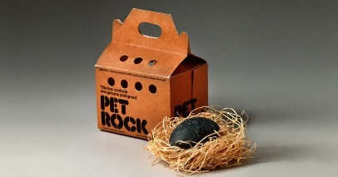  Make a pet rock- a popular homemade toy of the 1970s!
Research your family tree and find out what your relatives’ lives were like 1960s and 1970s. | Look at the art work of Roy Lichtenstein and be inspired to use his dot technique to create your own art
Research and write a biography about a prominent political figures of the 1960s-Harold Wilson, Edward Heath, James Callaghan, Martin Luther King, John F Kennedy | Research a 1960s/1970s savoury recipe and make it at home. Take photos and write out the recipe. Write a review of the meal.
On 30 July 1966 England won the football World Cup! Research the facts and write a news report | On 15 February 1971 decimalised currency replaced 'pounds, shillings and pence' Explain how the old money was calculated!
Space exploration was developing rapidly during the 1960s. Choose an exciting event to research and write about in a format of your choice e.g- factfile, newspaper report, powerpoint, fact filled poster…  1961-Yuri Gagarin becomes the first human in a space flight to orbit Earth!  1966- The Soviet Union launch Luna 10, which later becomes the first space probe to enter orbit around the Moon.  1968-First humans to leave Earth’s gravity and orbit another world: Apollo 8  1969, Armstrong and Buzz Aldrin became the first men to successful land and walk on the moon. | Research and draw or write about cartoons in the 1960s/1970s: Popeye, Space Angel, Wacky Races, Johnny Quest, The Bugs Bunny/ Roadrunner Hour, The Perils Of Penelope Pitstop, Dastardly and Muttley in Their Flying Machines, Scooby Doo, Where Are You!, Godzilla.
James Watson (born in 1928 ) American molecular biologist, geneticist and zoologist, with Francis Crick discovered DNA. Was awarded the Nobel Prize in 1962. What is DNA and why is it an important discovery. | Learn to play a 1960s/1970s song on a musical instrument and perform to the class. Popular music by the Rolling Stones, Elvis Presley, Beach Boys, Bob Dylan, The Monkees.
Research about new cars of the 1960s e.g.-the Capri (1961), Consul Cortina (1963) and Ford Escort (1968) Present your information in an interesting manner- perhaps a for sale advert! | Research and compare the difference in the price of things today and in 1960-1970 e.g- a loaf of bread cost 5p, a Manchester United season ticket cost just £8.50, the average house price was £2530! Display and present your findings as you wish- a Powerpoint, graphs,poster…
Read a children’s book published in the 1960s/1970s https://en.wikipedia.org/wiki/Category:1960s_children%27s_books and write a review e.g.- Famous Five adventures (Five On Finniston Farm, Five Go To Demon’s Rock…), The Borrowers Aloft, James And The Giant Peach, A Charlie and The Chocolate Factory, Fantastic Mr Fox, Wrinkle In Time, The Iron Man.. | Learn to do macrame! https://www.youtube.com/watch?v=KtJzYtxzUq4 (Ask an adult before you cut up t-shirts)

On 2 March 1969 Concorde, the world's first supersonic airliner, made its maiden flight! Find out about this plane and present the information in an interesting manner!

James Watson (born in 1928 ) American molecular biologist, geneticist and zoologist, with Francis Crick discovered DNA. Was awarded the Nobel Prize in 1962. What is DNA and why is it an important discovery?
WILDCARD HOMEWORK!  If you have an idea of a 1960s/1970s related topic you would like to research and write about please speak to your teacher! | WILDCARD HOMEWORK!  If you have an idea of a 1960s/1970s related topic you would like to research and create something about please to speak to your teacher!

Writing tasks may be hand written or typed.
You may present your work to the class or hand in just for your teacher to share with you.
You can produce PowerPoint presentations for a Writing Task but these should be written in your own words NOT copied and pasted from the Internet!
We hope you to enjoy doing your Topic Homework this term. We are certainly looking forward to seeing what you produce!

